
Sukkur IBA University
Department of Computer Science
ESE-201: Digital Logic Design Lab

Lab # 08: Multiplexer
Instructor: Muhammad Ismail Qureshi
Submission Profile
Name: Submission date (dd/mm/yy):
CMS ID: Marks obtained:
Comments: Receiving authority name and signature:

________________________________________________________________________________
Instructor Signature

Note: Submit this lab hand-out on LMS/e-learning before the next lab with attached solved activities and exercises.
Lab Learning Objectives:

Upon successful completion of this experiment, the student will be able:
- To implement and verify Multiplexer operations using 74LS153 IC & NI ELVIS Kit

Lab Hardware and Software Required:
- 74LS153 IC (1-to-4 Multiplexer)
- NI ELVIS Kit
- Breadboard
- Connecting Wires

Background Theory:

Multiplexer:
A Multiplexer (MUX) is a device that allows digital information from several sources to route on to single line common to destination. The basic multiplexer has several data inputs and a single output line. It has also a data select input, which allows digital information on the one input to be switched to be output line. Multiplexers are also called data selectors. The applications of multiplexer are many, and range from parallel to serial converters, register shifting, data transmission etc. Logic symbol and diagram for 2-input multiplexer is shown in Fig 8.1 (a & b):
Fig 8.1: (a) Logic Symbol for 2-input MUX (b) Logic Diagram for 2-input MUX

74LS153 MULTIPLEXER IC:
The TTL 74LS153 Multiplexer IC has two 4-input multiplexers. It has two selection inputs which act on both selectors, two enabling inputs which must be usually low, four inputs for each channel, and two outputs. Fig 8.2 shows the pin configuration of IC.
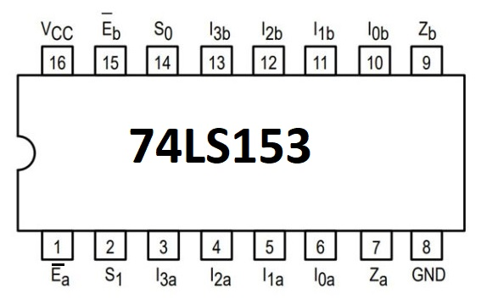

Fig 8.2: Pin configuration of 74LS153 MUX IC

Lab Examples:
Implementation of Multiplexer:
- Carry out the pin configuration of 74LS153 IC
- Take 74LS153 IC and insert it in the breadboard present on the NI ELVIS-II kit
- Apply power supply to it
- Connect inputs D0 and D1 to two data switches SW0 and SW1 and data switch S to another switch
- Connect the output Y to the LED
- Analyse the circuit behaviour by carrying out different combinations with the data switches and fill the observation table for multiplexer
Table 8.1: Observation table of Multiplexer
Input |  | Output (Y)
Select Input (Switch S) | Input Selected  (Data) | LED (on / off) | Level ( 1 / 0 )
0
1

Lab Activities:
Analysis of the Multiplexer 74LS153:
- Connect the data inputs C0 to C3 and select inputs A, B to switches
- Connect enable input EN to ground
- .Connect the output OUT to LED
- Change selection code by means of switches and test the operation of device completely
Table 8.2: Observation table of Multiplexer
Input |  |  | Output (Y)
Select Input |  | Input Selected  (Data) | LED (on / off) | Level ( 1 / 0 )
A | B

Lab Exercises:
What is multiplexer?

Using 74LS153 IC, make multiplexer circuit in Multisim and attach that circuit in here. Also write down circuit details.

